Warm Up

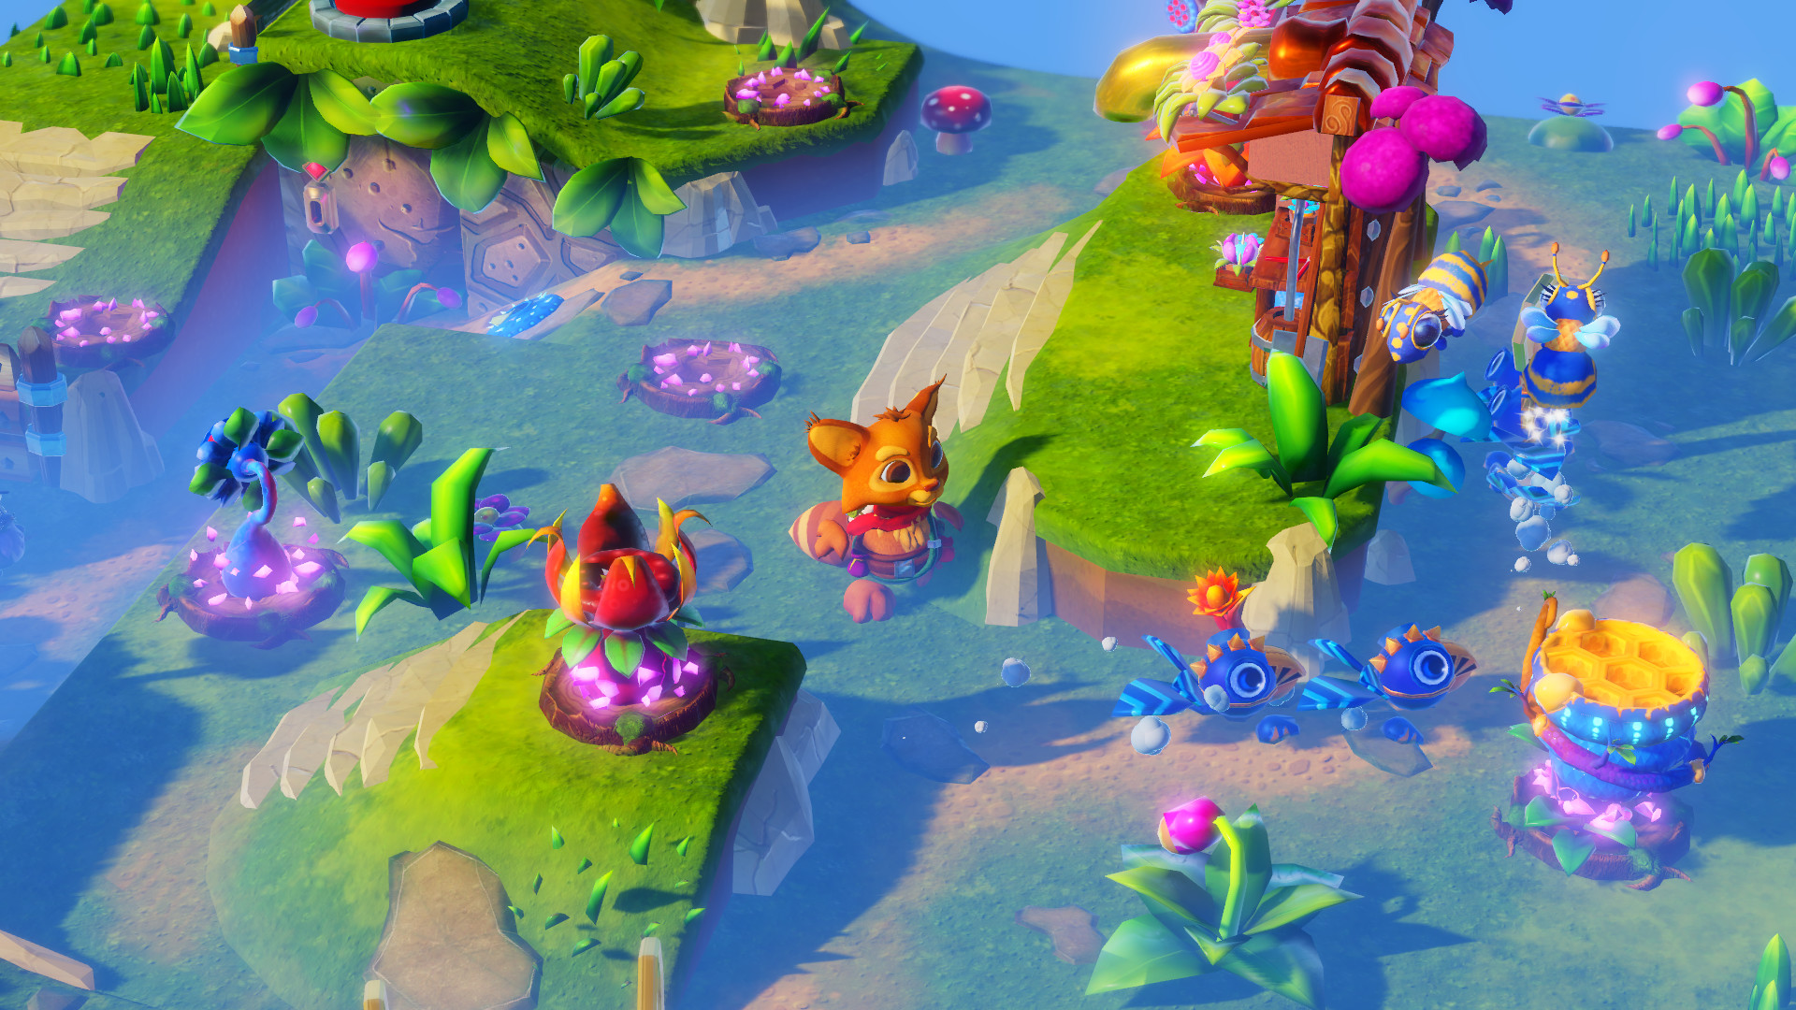

What do you think is involved in creating a game like this?